**[Game Title]: Game Design Document**

**Game Designers (your name & group members if any):Jack Ni**

**Date of Publishing:11/8/2020**

**High-Level Concept (one sentence to describe your game):**

**Players would need to plant plants to stop the waves of zombies from entering Crazy Dave’s house.**

**Game Goals: Players would need to plant the plants strategically on Crazy Dave’s lawn to prevent zombies from coming into the house and eat Crazy Dave’s brain. Players would have to defend numerous different levels of zombies and would have to beat the final boss.**

**Story Overview: There is a zombie apocalypse out there and all of the zombies are crazy for brains. The game starts off with a tutorial trying to teach the player on how to plant plants and explain what the plants can do and the purpose to plant them. Players do not have to travel or move since the only important task is to protect the zombies from entering Crazy Dave’s house and eating his brain. In order to protect Crazy Dave, players would have to plant the plants on the grids in his lawn. In the story mode, there are a total of 50 levels and in which the player would have to fight Dr. Edgar Zomboss at the last level. Beating the final boss means victory for the player since it means that the zombies have failed trying to come to the house.**

**Game Controls: In this game, the only control you need is to choose which plants you want to buy and where you want to place them. Players are allowed to control what kind of plants they want to purchase with the “sun” that can be obtained through time or from any sun-generating plants. Players are also allowed to place wherever they want to place the plants or even dig (destroy) the plants using a shovel.**

**Scoring: In this game, players can unlock most of the plants in this game by completing levels. Players can also obtain gold by defeating zombies in which they can be used to purchase more plants to be unlocked and even permanent in-game buffs from Crazy Dave’s Twiddydinkies.**

**Universal Game Mechanics: In this game, some of the important mechanics are that players need to know to place sun-generating plants to the furthest tile away from the zombies since these plants are the “income-generators,” without them, players cannot afford to purchase more plants. The next mechanic is that players need to know that most of the zombies can only walk and attack in straight horizontal rows, meaning that players usually should plant the first attacking plant on the row where the first zombie spawns from the right. Since this game goes by tiles, which means that players can only place one plant on each tile. Nonetheless, there are also special types of zombies in which the players should be aware of, like the bungee zombies that are capable of stealing plants from the sky for example. Players also would need to understand that there are so many different plants that have their own unique purpose, like the umbrella leaf in which can offer protection for the surrounding plants by blocking the bungee zombies from stealing any plants.**

**Game Progression (flowcharts suggested here):**

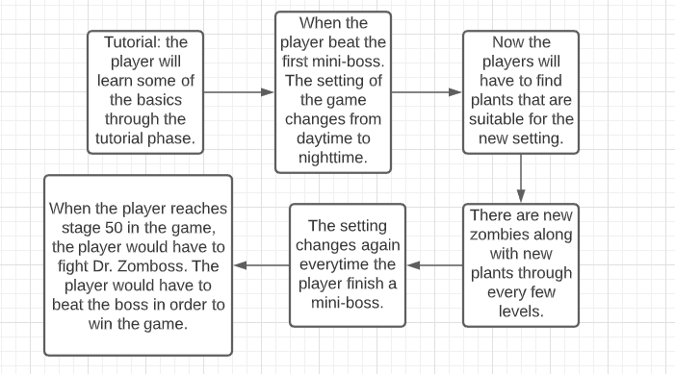

**Economy: In this game, the only in-game resource is sunlight. Players usually start off with 50 sun at the start of the game. Sunlight can be obtained from two ways, one of the ways to get sun is to get sunlight automatically when the setting is daylight, and it only provides 25 sunlight every 10 seconds. The other way is to plant any sun-producing plants, which brings sunlight every few seconds as well. This means that players will have to balance between growing more or less sun-producing plants in order to beat the specific level. Players can also obtain gold when defeating some zombies, these gold can be used outside of the game and can be used to buy more plants or purchase permanent in-game buffs that can assist the players throughout the levels.**

**State Modifier: Unfortunately, in this game, there aren’t any power-ups modifiers, but there are permanent buffs like extra seed slots or more powerful plants for example that players can purchase from the shop.**

**Technological Requirements: This game is a 2d game in which the camera is locked at a perspective during the game. There aren’t that many extra features that would require hard-coding. Since the game is going to be 2-D, this game is going to use Unity as the design tool. This is because Unity has great 2D tools and the features are more robust for the game designers.**

**Art Style Guide (include several images for each header)**

**Overall Art Style: The art style for this game is going to be cartoony and colorful. The plants are going to look colorful and that the plants will be based on real-life plants but with a bit of twist since normal plants cannot attack zombies. However, the zombies aren’t going to be that colorful, but they do have accessories or equipment that can be sort of colorful.**

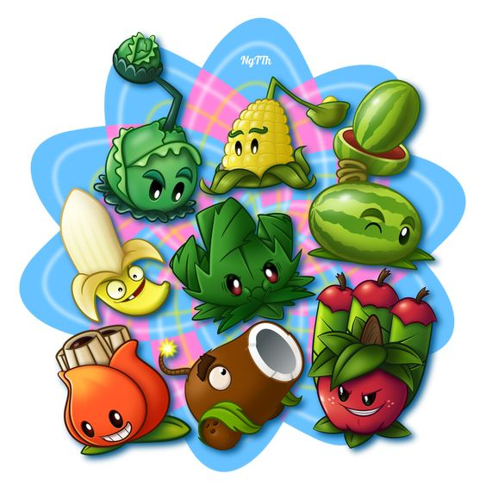https://pin.it/79mqoJW

**Color Palate: The colors for this game are mostly bright colors, like green or yellow, since the plants are the main characters in this game, and that most plants do have bright colors anyway.**

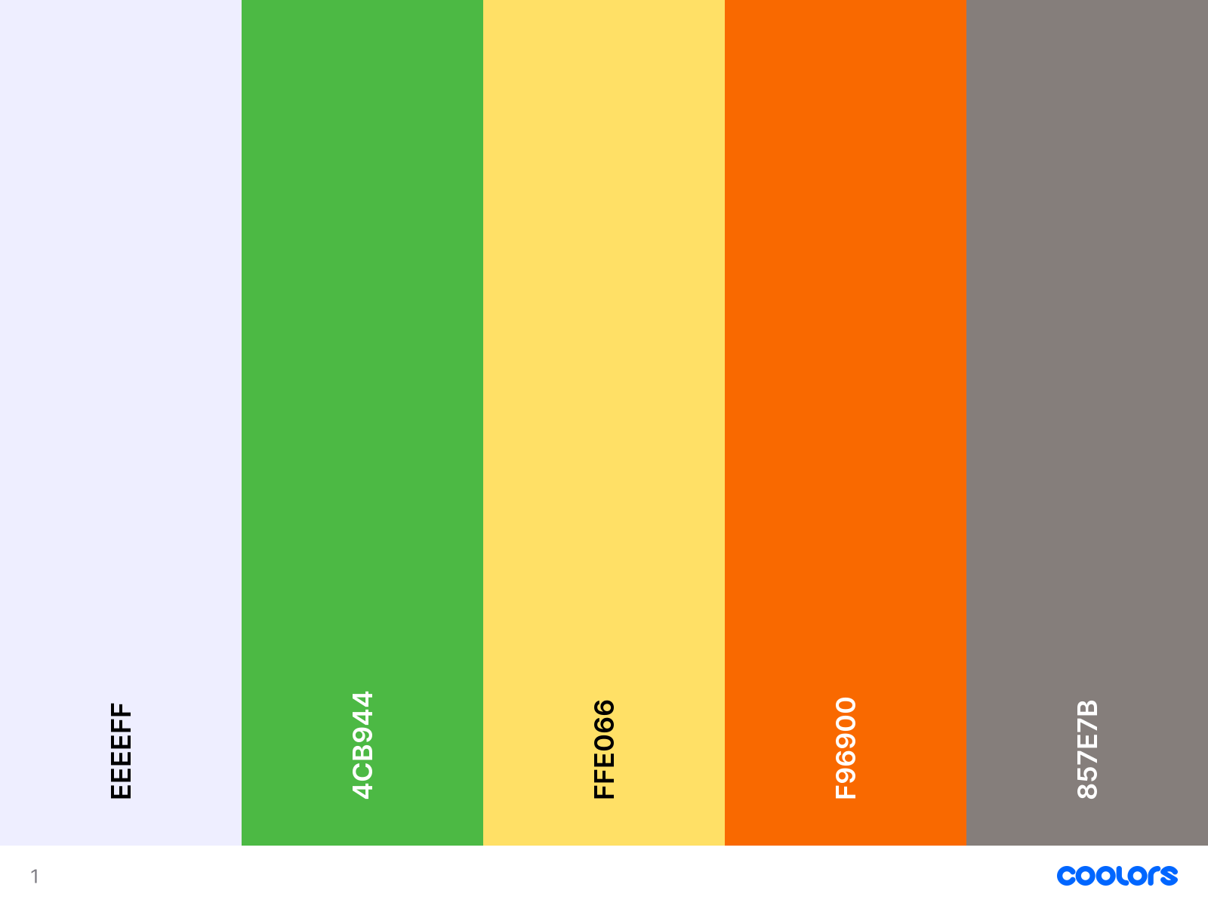

**Game World: In this game world, it seems that everybody except Crazy Dave are zombies, and that Crazy Dave’s only mission is to live and fight off the zombies using the different kinds of plants that can fight against the zombies when planted.**

**Characters: In this game, the main character in Crazy Dave, and he is the person that we have to protect in this tower defense game. If he gets eaten because any zombie manages to get past the defense in the game, then the player will lose the level and will have to try again.**